**GRADING/CGPA SYSTEM for LPU using FUZZY LOGIC**

**PROJECT REPORT**

***Submitted in partial fulfillment of the requirements for the award of the degree***

***of***

**BACHELOR OF TECHNOLOGY**

**(INT-254)**

**IN**

**COMPUTER SCIENCE AND ENGINEERING**



**Under the Guidance of Submitted By**

**Rajan Kakkar Uday Tripathi (12018460)**

**Professor Amritesh Raj (12016485)**

LOVELY PROFESSIONAL UNIVERSITY, JALANDHAR

**CANDIDATE’S DECLARATION**

___________________________________________________________________________

We hereby certify that the work, which is being presented in this report entitled, Fuzzy logic based expert system for student grading system for LPU, in partial fulfillment of the requirements for the degree of **Computer Science and Engineering** , Lovely Professional University, Phagwara, Punjab; by **Amritesh Raj (12016485), Uday Tripathi (12018460)** is the authentic record of our own work carried out under the supervision of **Professor Rajan Kakkar, Computer Science and Engineering**, Lovely Professional University, Phagwara, Punjab.

We further declare that the matter embodied in this report has not been submitted by us for the award of any other degree.

**ACKNOWLEDGMENT**

___________________________________________________________________________

It is our pleasure to acknowledge the contributions of all who have helped us and supported us during this Project report.

First, we thank God for helping us in one way or another and providing strength and endurance to us. We wish to express my sincere gratitude and indebtedness to our supervisor Rajan Kakkar, Professor, Computer Science and Engineering, Lovely Professional University, Phagwara, Punjab; for her intuitive and meticulous guidance and perpetual inspiration in completion of this report. In spite of her busy schedule, she rendered help whenever needed, giving useful suggestions and holding informal discussions. Her invaluable guidance and support throughout this work cannot be written down in few words. We also thank her for providing facilities for my work in the department.

We are also humbly obliged by the support of our group members and friends for their love and caring attitude. The sentimental support they rendered to us is invaluable and everlasting. They have helped us through thick and thin and enabled us to complete the work with joy and vigor. We thank the group members for entrusting in each other and following directions, without them this report would never have been possible.

We are also thankful to our parents, elders and all family members for their blessing, motivation and inspiration throughout our work and bearing with us even during stress and bad temper. They have always provided us a high moral support and contributed in all possible ways in completion of this report.

TABLE OF CONTENTS

1. ABSTRACT

2. PROFILE OF THE PROJECT

3. INTRODUCTION

4. WHAT IS FUZZY LOGIC ?

5. WHY FUZZY LOGIC IS USED?

6. FUZZY LOGIC ARCHITECTURE

7. FUZZY LOGIC MEMBERSHIP FUNCTION

8. IMPLEMENTATION OF FUZZY LOGIC(ALGORITHM)

9. APPLICATIONS OF FUZZY LOGIC

10. LIMITATIONS OF FUZZY LOGIC

11. METHODS

12. SOFTWARE REQUIREMENTS

13. DESIGN

14. IMPLEMENTATION

15. TECHNICAL AND MANAGERIAL LESSONS LEARNT

16. CONCLUSION

17. CURRENT STATUS OF THE PROJECT

**ABSTRACT**

_________________________________________________________________________________

Decision-making is an integral aspect of our daily lives. It is hard to establish whether a certain statement (or state) is true or false in certain situations. In such situations, fuzzy logic can be used to offer flexibility in reasoning, given the uncertainty.

Fuzzy logic systems are used in automobile and domestic applications to control actions and processes. This article provides an overview of this logic and how it is implemented. It also highlights its real-life applications and explains why it is used.

It consists of rules, facts and conclusions. The fuzzy production rules connect premises with conclusions, and condition with action

At the end, the user is able to calculate students CGPA and store them in Database.

**Profile of the Project**

_________________________________________________________________________________

The project vital role is to compute the cgpa for a student by taking input from user or from a database that is already exist. It should be made through the fuzzy logic which is maintained by set of rules that are built by the user in the specific logic by importing the values from a module.

Scikit-fuzzy is the module through which a fuzzy logic methods to be implemented in the module that is built to calculate cgpa. Membership functions in fuzzy plays important role whether taking the values should be random or to be from the database or from the user or random values in the given range of values or a given set of values.

GUI is also used to make it more compatible and more visual looking to be understand easily by only looking onto it. It allows user to choose what he had to do and help in understanding easily. A base window is created for choosing what to do, a login or signup page to access the user or to register the user.

**CHAPTER 1: INTRODUCTION**

One of the most attractive technologies is mobile technology which represents a revolutionary approach to education. In recent times mobile devices have been steadily incorporated into learning. The broad use of Smartphones and different transportable and Wi-Fi gadgets has converted the traditional teaching method and learning process. This extensive usage of mobile devices has fetched loads of mobile application in English Language Teaching. Numerous apps are available for language learners to download through easy access to the internet. Learning materials can be accessed easily due to the portability and accessibility of mobile devices.

**1.1 THE CONCEPT OF M-LEARNING :**

In this technological era, everyone has their own handheld mobile devices. Using these devices, with easy access to internet, they interact with people from anywhere in the world. Irrespective of time and place people chat or exchange information with each other. .The very term “mobile” stands for the “mobility” or the ability to move freely and easily from one place to another. Mobile learning refers to the implementation of mobile devices in any branch of study. The features of mobile technology such as the portability and information accessibility plays a major role in the enhancement of English language teaching and learning

The main characteristic of M-Learning can be the discretion of the learner. It lies in the hands of the learner to decide upon the place and time for language learning. The outbreak in the domain of mobile learning makes it harder for anyone to arrive at a stable concept because of the availability of new mobile devices in the market. Generally, mobile learning can be defined as mobility of the personal, portable and wireless devices such as the Smartphone, personal digital assistant (PDA), iPod, palmtop, laptops used in language learning. Mobile learning can be divided into

• “Mobility of technology”

• “Mobility of learner”

• “Mobility of learning”

The Mobility of technology refers to mobile devices with Wi-Fi capacities and Wireless Application Protocol (WAP) that deliver information and learning materials through the internet. According to Hui Guo “Mobile learning increases the mobility of learners. With portable and personal mobile devices, learners could be engaged in more flexible, accessible and personalized learning practices without constraint on places”. Mobile learning enhances the mobility of learning process without time constraint.

What is fuzzy logic?

Fuzzy means uncertain, indefinite, vague, or unclear. Fuzzy logic is a computing technique that is based on the degree of truth. A fuzzy logic system uses the input’s degree of truth and [linguistic variables](https://www.igi-global.com/dictionary/granular-computing/17211) to produce a certain output. The state of this input determines the nature of the output.

This technique is different from [boolean logic](https://www.bbc.co.uk/bitesize/guides/zc4bb9q/revision/1), which uses only two categories (true or false). In boolean logic, two categories (0 and 1) are used to describe objects. For example, the temperature in water served in glass may be High (1) or Low (0). The water is described using more categories in fuzzy logic, but within the two categories mentioned earlier. In this case, the water may be very cold, very warm, or warm.

Let’s take another simple example. Suppose we have a question that we need to answer. In boolean logic, the answer would be either yes or no. In fuzzy logic, the answer may be between these two categories. Some of the probable answers in this logic may include possibly yes, possibly no, or certainly no.

We learn that fuzzy logic systems use degrees of possibilities rather than precise categories in the above two examples. These are used to generate an explicit output.

Why fuzzy logic is used ?

* It solves the problem of uncertainty in the engineering field.
* When accurate reasoning is not available, it provides an accurate level of reasoning.
* Fuzzy logic has a simple structure that is easy to understand.
* It is an effective way of controlling machines.
* It provides solutions to various industrial problems (especially decision making).
* It requires little data to be executed.

Fuzzy logic architecture

The following diagram shows a fuzzy logic architecture.

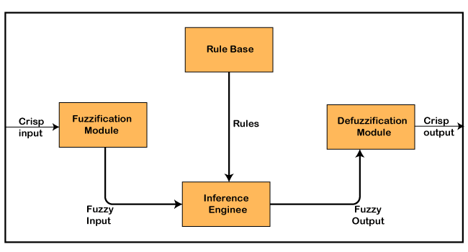

The fuzzy logic architecture consists of the following components:

* **Rule Base:** This contains the rules and membership functions that regulate or control decision-making in the fuzzy logic system. It also contains the IF-THEN conditions used for conditional programming and controlling the system.
* **Fuzzifier:** This component transforms raw inputs into fuzzy sets. The fuzzy sets proceed to the control system, where they undergo further processing.
* **Inference Engine:** This is a tool that establishes the ideal rules for a specific input. It then applies these rules to the input data to generate a fuzzy output.
* **Defuzzifier:** This component transforms the fuzzy sets into an explicit output (in the form of crisp inputs). Defuzzification is the final stage of a fuzzy logic system.

### Fuzzy logic membership function

A membership function is a graphical representation of a fuzzy set. It shows how values ranging between 0 and 1 are mapped to inputs. Inputs are generally represented as Universe (U).

Any value within the range of 0 to 1 indicates a degree of membership. Each element of the Universe (X) is given a specific degree of membership.

In simple terms, the membership function is used to estimate or compute the degree of membership of a certain input element in a specific fuzzy set. The Universe is on the x-axis, while the degrees of membership are on the y-axis.

The following diagram shows an example of a membership function.

### Membership Function

### Implementation of fuzzy logic (algorithm)

The fuzzy logic technique can be implemented in various systems (hardware and software). A simple, practical example of a fuzzy logic system can help us understand how fuzzy logic is implemented.

Suppose we want to design a fuzzy logic system for an air conditioner. The fuzzy logic system ensures that the air conditioner sets the desired temperature. If there is a disparity between the desired temperature and the room temperature, the air conditioner will employ the fuzzy logic to adjust the temperature to the desired value.

The following are the main algorithmic steps for fuzzy logic.

**Step 1:** We should first define the linguistic terms (or variables). In Boolean logic, the temperature can be categorized into two main categories: hot and cold.

In a fuzzy logic system, we can use linguistic terms to describe different categories of temperature. Some of the linguistic terms used in our case include very cold, hot, very warm, warm, cold, and very hot. Temperature can be termed as a fuzzy set t consisting of the aforementioned linguistic terms.

**Step 2:** After defining the linguistic terms, we should create membership functions. This step involves providing a graphical representation of our fuzzy set (t). The input temperature is on the x-axis, while the degrees of membership are on the y-axis.

The membership function computes the degrees of membership of various temperature elements.

**Step 3:** In the third step, we will construct rules for controlling the air conditioner’s temperature. Here, we can apply the IF-THEN logic to set effective rules. For example, the following IF-THEN conditions can be made.

* IF the room temperature is very cold, and the desired temperature is very warm, THEN heat.
* IF the room temperature is very hot, and the required temperature is cold, THEN cool.
* IF the room temperature is warm, and the required temperature is warm, THEN no action should be taken.

In the three IF-THEN conditions, heat, cool, and no action represent the actions that need to be taken after the IF-THEN conditions have been met.

**Step 4:** After setting the system’s rules, the fuzzifier uses them to transform the raw input into fuzzy sets. This is done through fuzzy operations (e.g., Max and Min). These fuzzy sets are used to generate a membership function output.

**Step 5:** Defuzzification: This is the last algorithm step. In this step, the defuzzifier uses the membership function to establish the output temperature.

### Applications of fuzzy logic

#### **Automobile industry**

Automobile companies use fuzzy logic systems in cars to prevent a collision. Fuzzy logic regulates the braking system using input elements such as momentum, speed, and acceleration.

Car manufacturers also use this system to regulate fuel injection. This is done using input elements such as load capacity, engine RPM, and temperature.

#### **Aviation industry**

Aircrafts use this technique to maintain a certain level of altitude. IF-THEN conditions are applied to ensure that the aircraft performs corrective measures if it is not within the desired altitude. For example, if the desired cruising altitude is 40,000 ft above the sea level, the fuzzy logic will enable the aircraft to return to this level if it goes above or below it.

#### **Domestic applications**

Fuzzy logic is used in various domestic applications such as air conditioners, televisions, vacuum cleaners, and refrigerators. It’s also used in washing machines to control water intake, washing, spin speed, and the time spent in washing.

The input elements include the size of clothes, type of dirt, and dirt level (degree). If the clothes are large and greasy, the washing machine will allow a large amount of water from the tap. The machine will take a long time to wash these clothes because of the large size of the clothes and the nature of the dirt.

### Limitations of fuzzy logic

* It does not recognize patterns relating to machine learning.
* It is hard to set concrete rules for a specific problem.
* The validation of a fuzzy logic system requires thorough testing.
* It uses imprecise data, which may sometimes make it generate inaccurate results.

Methods we used to create this Project

Fuzzy logic is used for solving problems in expert systems and real time systems that must react in an imperfect environment with highly variable, volatile or unpredictable conditions. A fuzzy set is a class of objects in which there is no sharp boundary between objects . In much real world application, fuzzy systems that make use of linguistic rules are appropriately suited to describe this natural behavior which is difficult to model mathematically .

The system primarily designed to represent and provide reasons with some particular form of knowledge and is widely used in decision-making to cope with uncertainty. It implies that the reasoning process is stated in terms of approximations.

However this approximate reasoning is applied to precisely stated (numerical) inputs, and will produce precise numerical outputs. Fuzzy logic uses crisp values as inputs to a model and defuzzification procedure to obtain single scalar value.

Now we will give inputs and get the outputs accordingly, this contain types

Fuzzification :

Input variables = Marks,Extra curricular activities, Behavior or Attendance.

Output variables = CGPA (Average, Good, Excellent).

In this step, real variables are transformed to linguistic variables with several terms. Fuzzification also involves assigning a set of predefined fuzzy membership functions to the inputs so that data can be transformed into a set of meaningful observations for fuzzy inference engine.

Membership function need to be assigned to each fuzzy subset. In general, membership functions are developed by using intuition and qualitative assessment of the relations between the input variables and output classes. Trapezoidal membership function was chosen since its simplicity often allows for more prediction and calculation of a system output .

Fuzzy Interference:

This step resembles human reasoning in its utilization of approximate information and uncertainty to generate decisions. It consists of rules, facts and conclusions. The fuzzy production rules connect premises with conclusions, and condition with action.

In this inference, expert’s knowledge and experience were acquired and formulated accordingly to develop the appropriate rule to perform the system.

Fuzzy inference matches fuzzy facts against fuzzy conditions and assigns a fuzzy set. If x then a or if x2 then a2 etc are conditions. It need to check multiple conditions and show us the output.

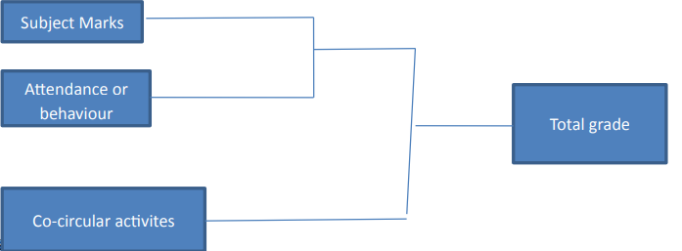

Software Requirements

The can be produced through many softwares such as Sublimetext editor, Anaconda and so on. We had used Anaconda software to write the logic of fuzzy, to calculate marks, for GUI and for creating database respectively. This also can be done using MATLAB.

• The software should be up to date.

• Workbench required to create database should be installed.

• Scikit module should be implemented.

• GUI modules should be installed

Other Sources of Requirements

• Knowledge transfer from team members already working on that project

• Talk about project to business analyst, product manager, project lead and developers.

• Analyze previous system version that is already implemented into the system

• Analyze the older requirement document of the project

• Look into the past Bug reports, some of the bug reports are turned into enhancement request which may be implemented into current version

• Look into installation guide if it is available to see what are the installation required

• Analyze the domain or industry knowledge that team is trying to implement

Design

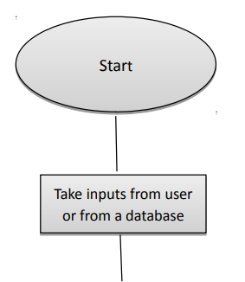

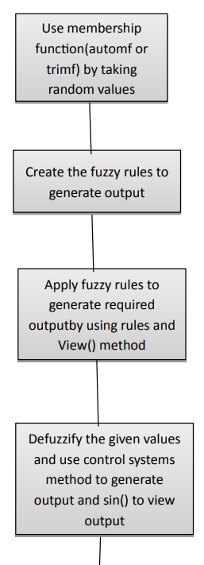

Implementation:

For the evaluation of the student on different metrics and to attain an near accurate grade the rules which our fuzzy system will work on have to be precise. Also, a good user-interface is a must for the ease of students.

So for that our team will be distributed in two sub-teams where one team will work on maintaining good user interface and the other will work on designing the fuzzy system, and in the end we will merge the graphical user-interface to the fuzzy system.

For the graphical user-interface tkinter module will be used and for fuzzy logic system scikit-fuzzy will be used.

The metrics on which the student will be evaluated can be mid-term marks, endterm marks and class-assessment marks of different subjects, also there can be marks on attendance.

Grades can also improve by increase in co-curricular activites and many more.

Technologies Learnt

Technologies learnt during the project are also used in the project that include Anaconda Navigator which helps in installing and importing the modules. Each and every technique and technology are known and best to our knowledge in using and applying their methods and modules.

• Database

• Python

• Scikit- learn

Conclusion

Fuzzy terms can be used to represent academic performance evaluation that involves the measurement of capability, know-how and skill. Moreover, fuzzy logic imitates the way humans make decisions using linguistic reasoning’s.

Reasoning based on fuzzy approach is likely to offer an alternative way of handling imprecise data, especially in making decisions and judgments. This is important in providing a platform for the application of Fuzzy Logic in evaluating student’s academic performance. There are several advantages for using the evaluation procedure were obtained from this study. These include:

a) In the Fuzzy approach, membership values are assigned to the variables in order to reduce the rigidity of decision border which is used in classical statistical method. Thus the new score obtained from fuzzy approach can be used to assist the decision making process .

b) The employment of fuzzy approach allows human-like reasoning which is more natural in making decisions. This is represented by if-then statement that considerate the lingual term.

c) Fuzzy logic is likely promise for a properly information processing in the linguistic hedges term. This is demonstrated by the linguistic hedges such as ‘very’, and ‘more or less’ that allow more flexible judgments as compared to numerical values, particularly when assessing student achievement and performance.

The main concern of every academic institution is to produce quality students that can easily be employed upon graduation. Evaluating student achievement is not only about the academic performance but there are many other factors to be considered to provide a good and complete assessment.

Therefore, we need to identify a better way to do the assessment in order to attain an effective and reliable result not only for the academic institutions but also for the employers and the society at large.

In summary, two major contributions can be drawn out from this research; namely the application of fuzzy reasoning in student’s performance evaluation and secondly, the consideration of more than one factors in classifying student’s performance achievements.

**Current status of the project: -**

The following pictures show the current status of our project :-

Main welcome page: -

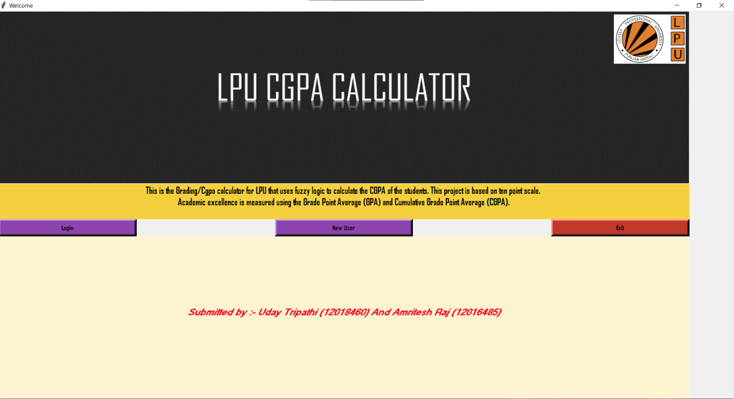

New user before entry

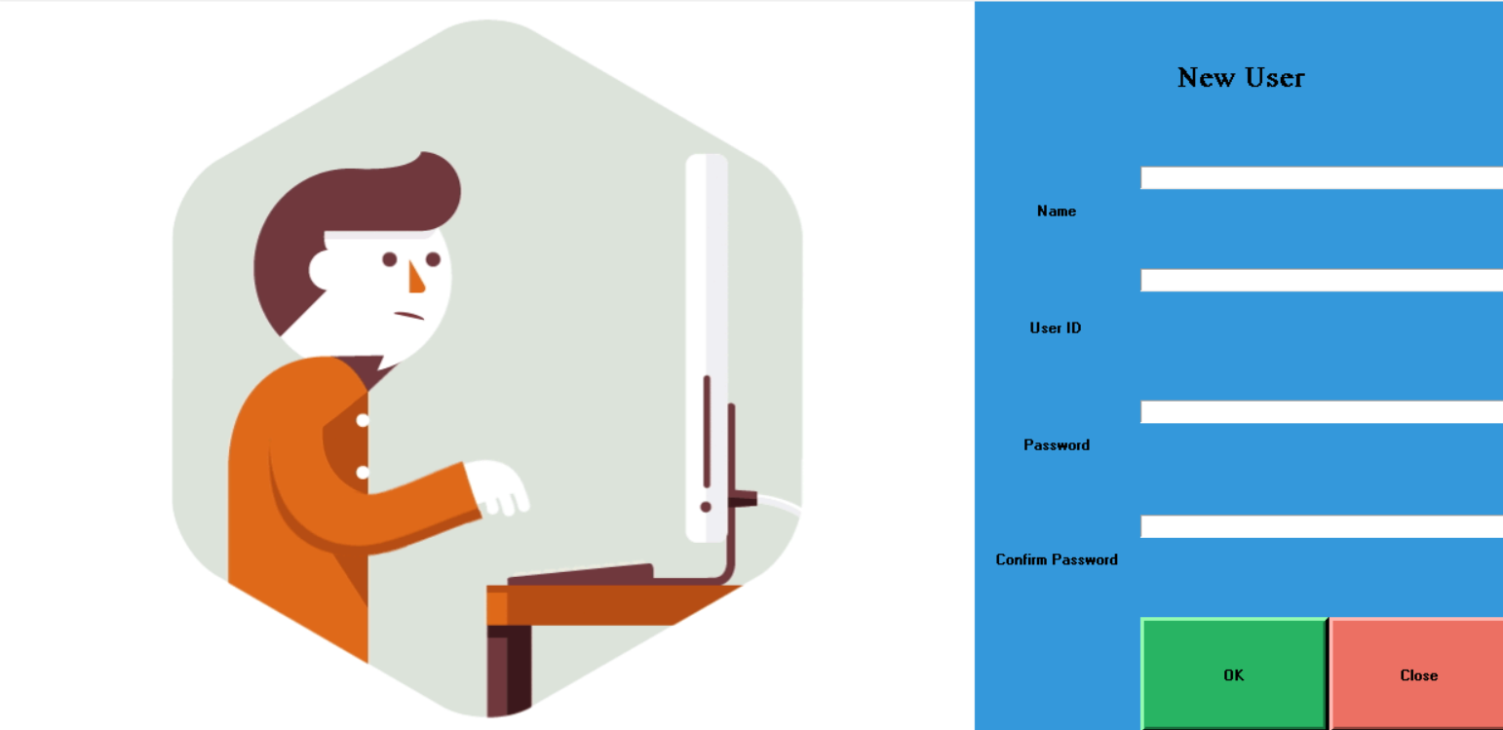

After entry

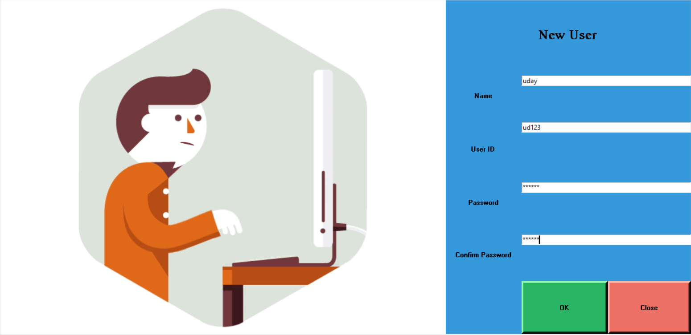

Before entry

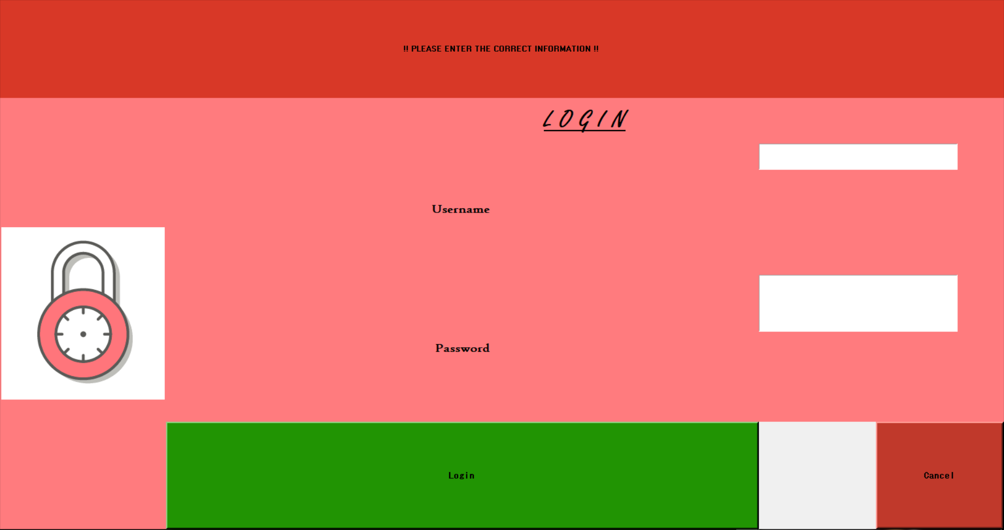

After entry

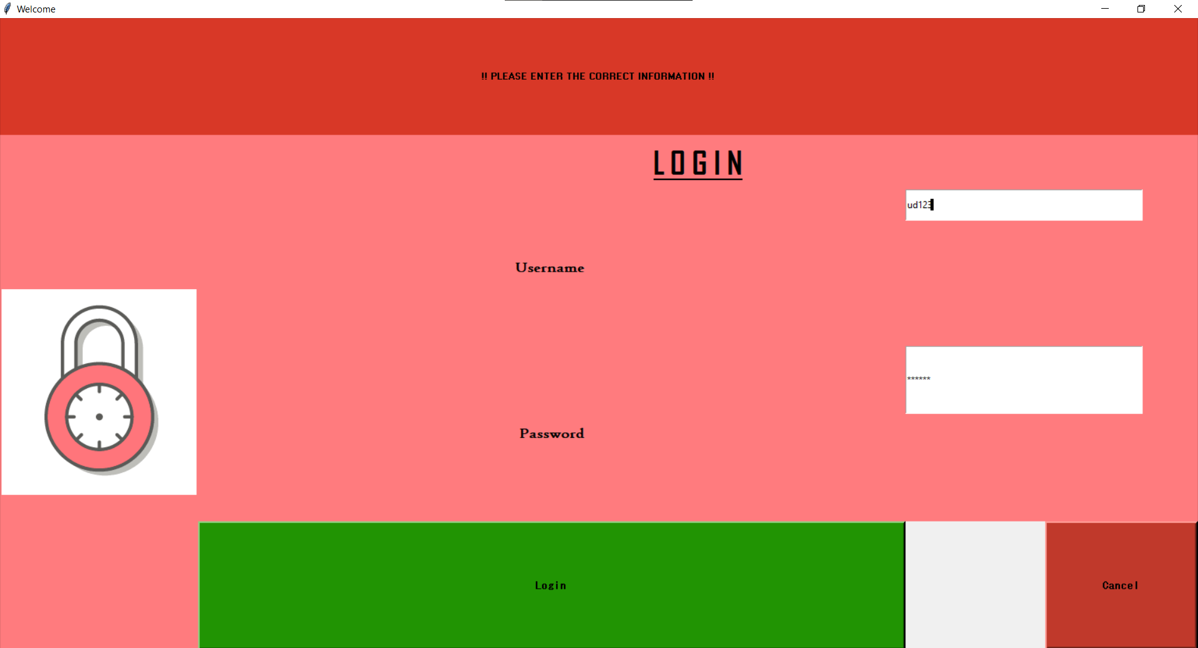

Before results.

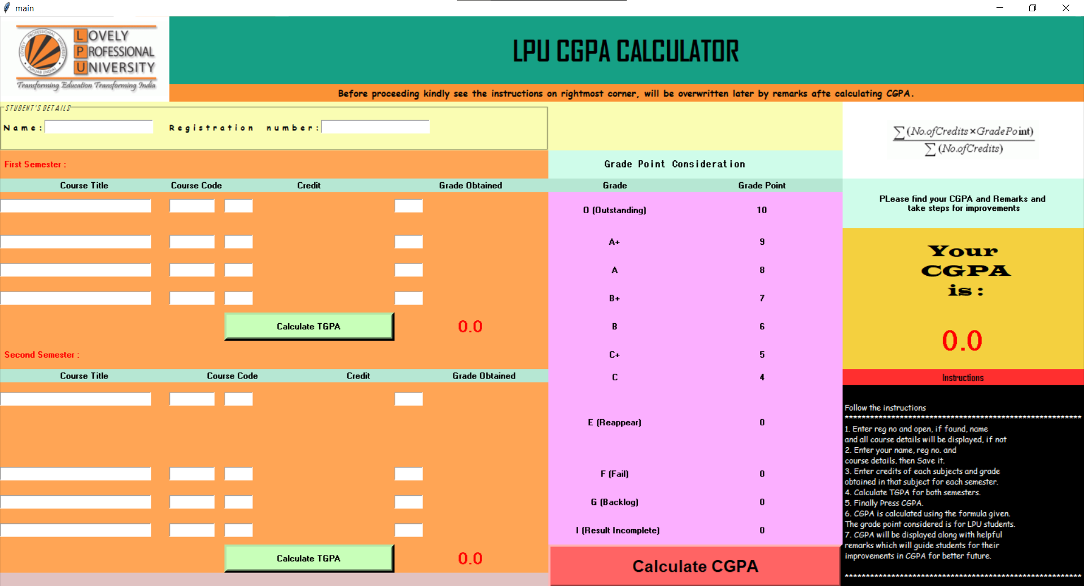

After entry before calculating

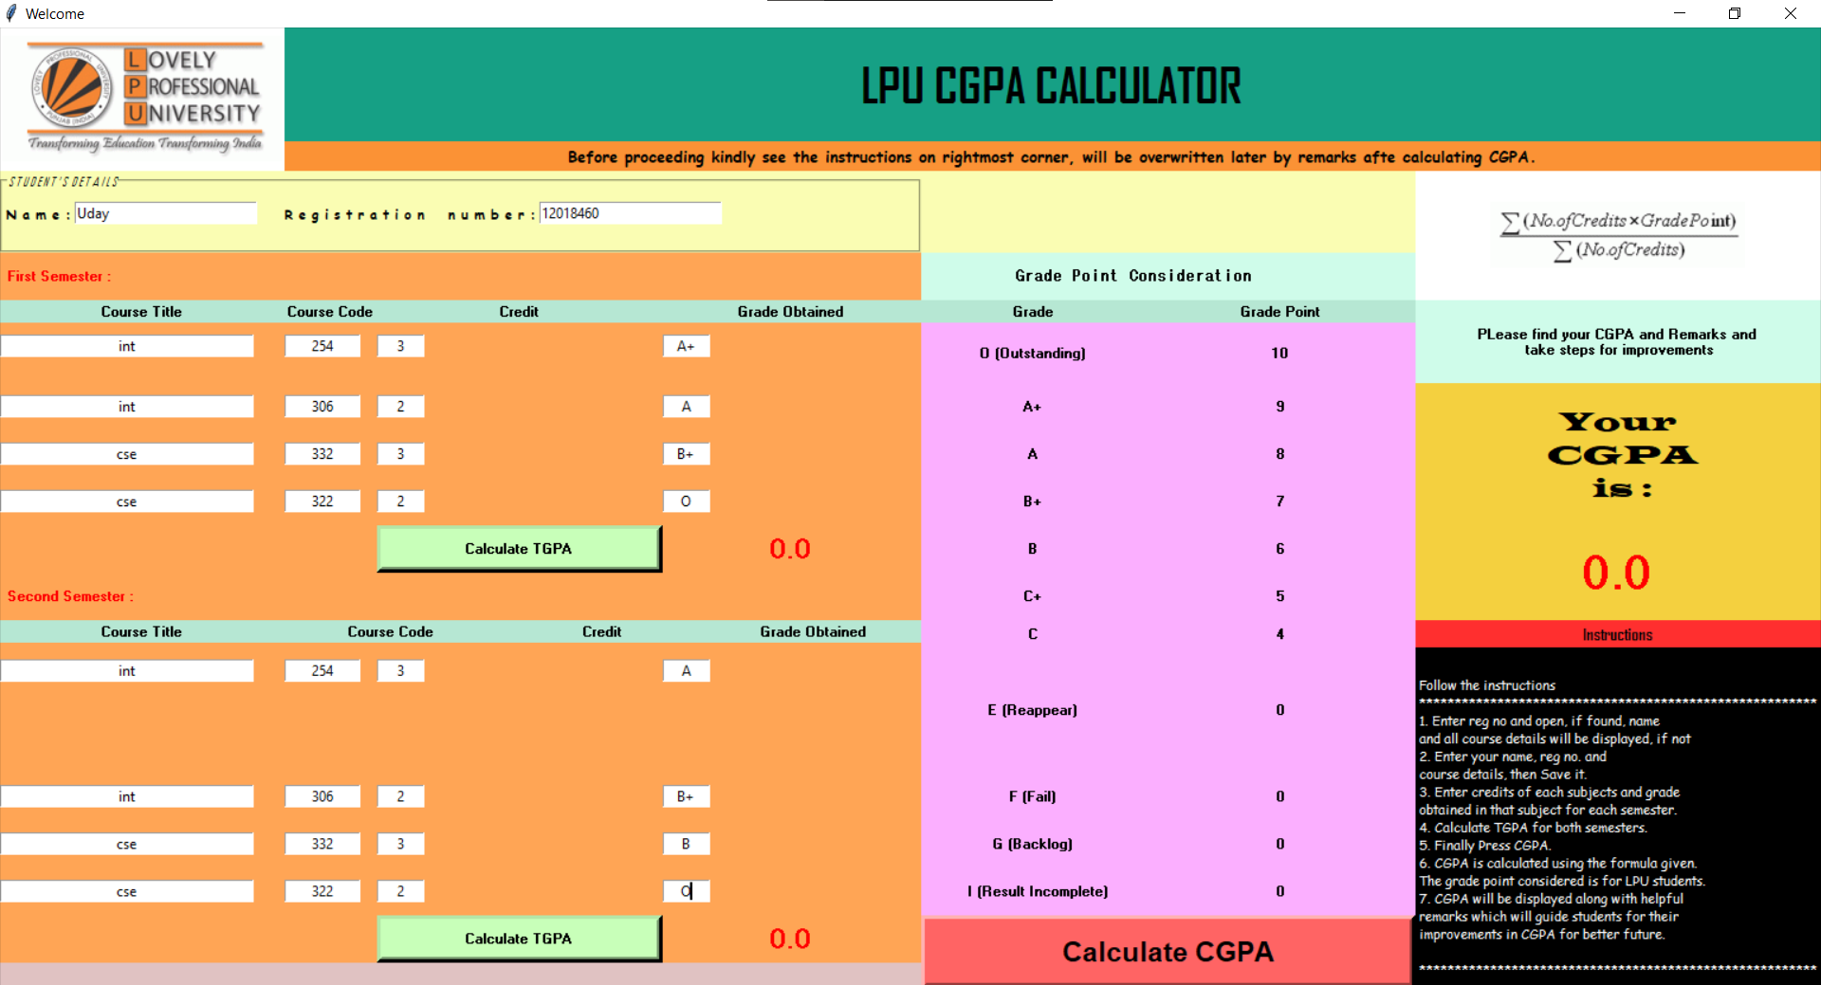

After calculating

